Sheet 2

Computing Algorithms
Q1: in the following code segments define the basic operation and use mathematical analysis to prove how many times the basic operation was executed: T(N)
- x <-0
for i <- 1 to n
x<- x+1
end
- x <-0
for i <- 1 to n
x<- x+1*2
end
- x <-0
for i <- 1 to n
x<- x+1
x<- x+x
end
- x <-19
for i <- 1 to n
x<- x-1
x<- x+x
end
- x <-0
for i <- 1 to n
for j<-1 to n

x<- x+1
x<- x+x
end
end
- x <-0
for i <- 1 to n
for j<-1 to i
x<- x*2
x<- x/3
end
end

Q2: Consider the definition-based algorithm for adding two n × n matrices. a. What is its basic operation? How many times is it performed as a function of the matrix order n? As a function of the total number of elements in the input matrices? b. Answer the same questions for the definition-based algorithm for matrix multiplication.
Q3: Glove selection There are 22 gloves in a drawer: 5 pairs of red gloves, 4 pairs of yellow, and 2 pairs of green. You select the gloves in the dark and can check them only after a selection has been made. What is the smallest number of gloves you need to select to have at least one matching pair in the best case? In the worst case?
Q4: For each of the following functions, indicate how much the function's value will change if its argument is increased fourfold.
a$.log_{2}\left(n\right)$ b. $√$n c. n d. $n^{2}$ e. $n^{3}$ f. 2"
Q5: List the following functions according to their order of growth from the lowest to the highest:
$$(n-2)!,5log⁡(n+100)^{10},2^{2n},0.002n^{4}+3n^{3}+1,\ln^{2}⁡n,\sqrt[3]{n},3^{n}$$
Q6: For each of the following pairs of functions, indicate whether the first function of each of the following pairs has a lower, same, or higher order of growth (to within a constant multiple) than the second function.
- $100n^{2}$ and $0.01n^{3}$
- $Log_{2}^{2}(n) and log_{2}n^{2}$
- $(n -1)! and n!$
- $n(n +1) and 2000n^2$
- $log_{2}(n) and In(n)$
- $2^{n-1} and2^{n}$
Q7: For each of the following algorithms, state what the basic operation is, how many times it is executed, T(n), and its order of growth, g(n).
a.
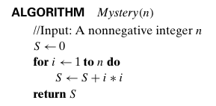

b.
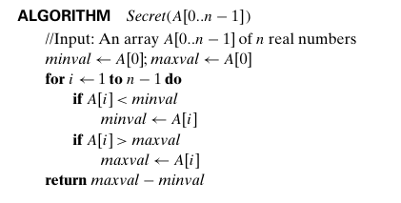
c.
